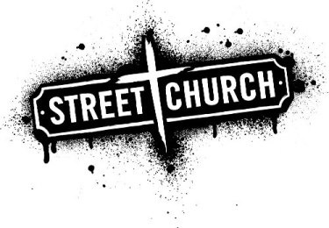
Dear Church Leaders
Many of your congregations will already be supporting the work of StreetChurch and I would ask you to pass on our heartfelt thanks for their support throughout 2016. Without their generosity both financially, in kind and in their time we would not be able to be a family to the homeless and severely disadvantaged in Northampton. The love our caterers and volunteers pour out makes an enormous difference to the lives of those who are unloved by society.
Whilst StreetChurch does need ongoing financial support what we urgently need in 2017 is a few more committed volunteers to join our core team (volunteers must be at least 18 years old). If you have members of your congregation with a heart for the disadvantaged who are seeking a way to serve, Streetchurch offers them a way to test out their calling. Not everyone has the ability to connect with those living rough or with drug or alcohol addictions; giving them unconditional love. Volunteering with StreetChurch gives someone the opportunity to test out their calling without making a long term commitment. Volunteering could even be part of a discipleship programme.
We are looking for individuals who can connect with our friends and who can commit to attending for 3 Sundays every 5-6 weeks. This could even be for a short period of a couple of months. The key is a period of consistency of attending 2 or 3 Sundays in a row to build up trust with the friends. If you know members of your congregation who either have the heart or the potential to develop Christian love for the disadvantaged please put them in touch with us. We are happy for individuals to come and see if it is for them before they commit. Please ask them to contact one of the following to discuss the opportunities:
Rev Jennie Crane, Castle Hill URC, jenniecrane1967@hotmail.co.uk, mobile 07976 979791
Paul Edwards, Mount Zion Church, pedwards611@gmail.com, mobile 07541 625324
Maj Jason Snell, Salvation Army, jason.snell@salvationarmy.org.uk, tel: 01604 470257
I have attached a copy of our 2016 annual report which outlines our achievements and challenges in 2016.
Many thanks, God bless
Allan Chesney
Chair of StreetChurch
Allan_chesney@btinternet.com

